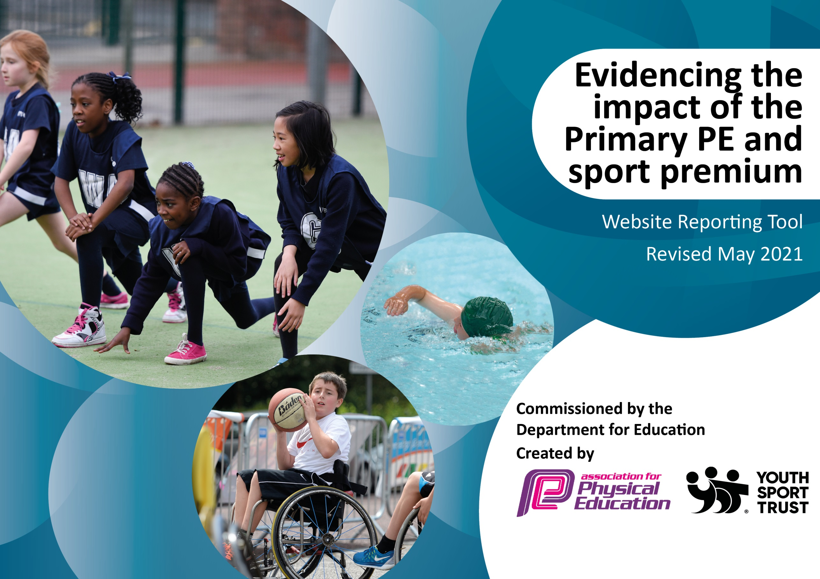

It is important that your grant is used effectively and based on school need. The Education Inspection Framework (Ofsted 2019 p64) makes clear there will be a focus on ‘whether leaders and those responsible for governors all understand their respective roles and perform these in a way that enhances the effectiveness of the school’.

Under the Quality of Education criteria (p41) inspectors consider the extent to which schools can articulate their curriculum (INTENT), construct their curriculum (IMPLEMENTATION) and demonstrate the outcomes which result (IMPACT).

To assist schools with common transferable language this template has been developed to utilise the same three headings which should make your plans easily transferable between working documents.

Schools must use the funding to make additional and sustainable improvements to the quality of Physical Education, School Sport and Physical Activity (PESSPA) they offer. This means that you should use the Primary PE and sport premium to:

- Develop or add to the PESSPA activities that your school already offer
- Build capacity and capability within the school to ensure that improvements made now will benefit pupils joining the school in future years
- The Primary PE and sport premium should not be used to fund capital spend projects; the school’s budget should fund these.
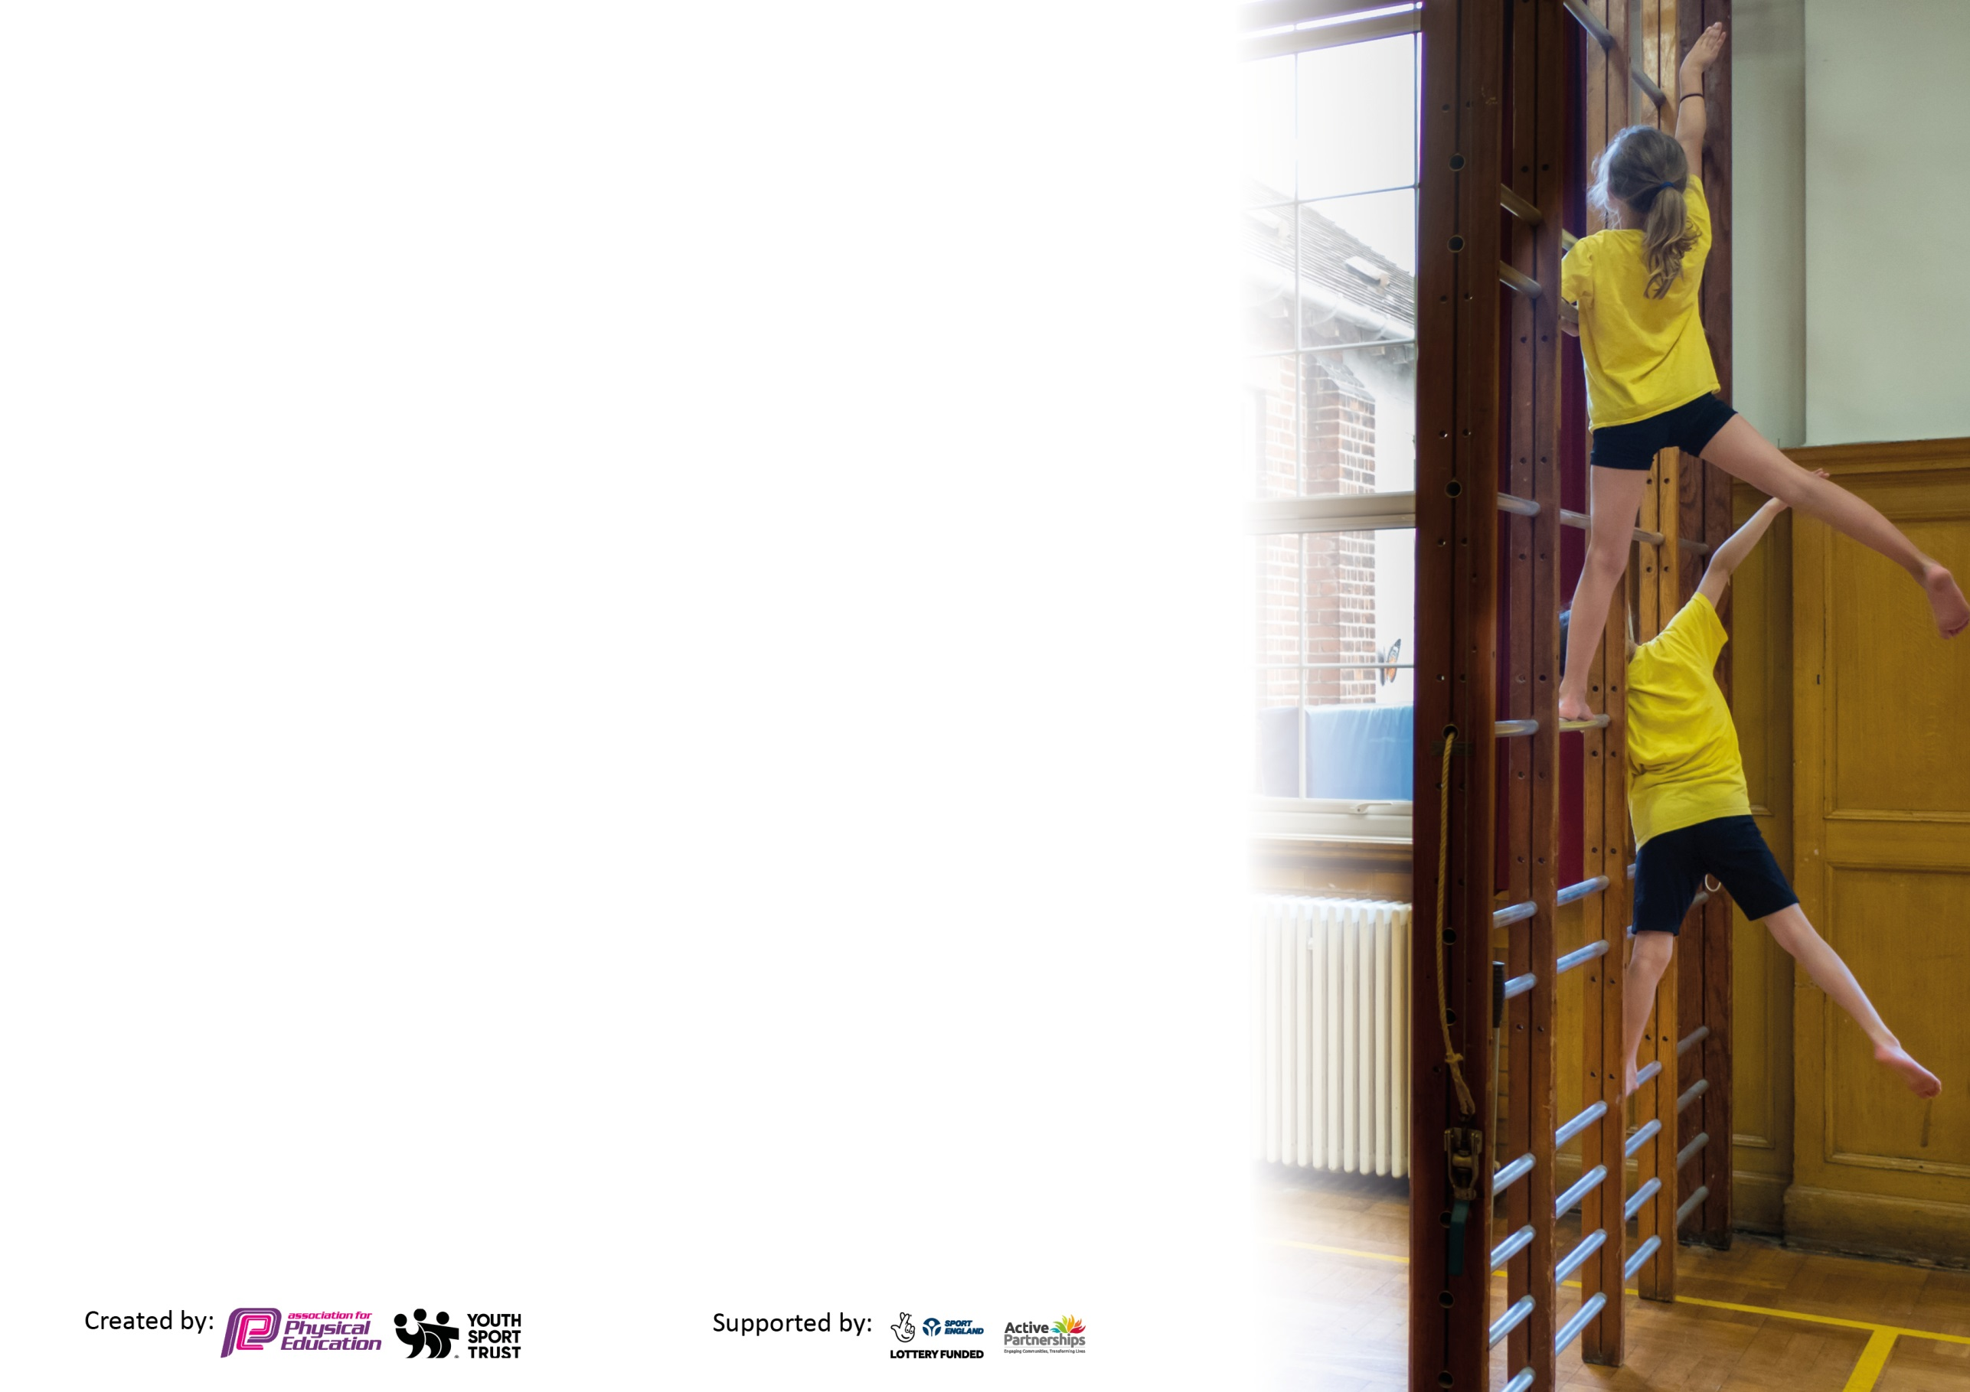
Please visit gov.uk for the revised DfE guidance including the 5 key indicators across which schools should demonstrate an improvement. This document will help you to review your provision and to report your spend. DfE encourages schools to use this template as an effective way of meeting the reporting requirements of the Primary PE and sport premium.

We recommend you start by reflecting on the impact of current provision and reviewing the previous spend.

Schools are required to publish details of how they spend this funding, including any under-spend from 2019/2020, as well as on the impact it has on pupils’ PE and sport participation and attainment by the end of the summer term or by 31st July 2021 at the latest.

We recommend regularly updating the table and publishing it on your website throughout the year. This evidences your ongoing self-evaluation of how you are using the funding to secure maximum, sustainable impact. Final copy must be posted on your website by the end of the academic year and no later than the 31st July 2021. To see an example of how to complete the table please click HERE.

Please note: Although there has been considerable disruption in 2020 -21 it is important that you publish details on your website of how you spend the funding - this is a legal requirement.
Support for review and reflection - considering the 5 key indicators from DfE, what development needs are a priority for your setting and your pupils now and why? Use the space below to reflect on previous spend and key achievements and areas for development.

N.B. In this section you should refer to any adjustments you might have made due to Covid-19 and how these will influence further improvement.
Key achievements to date until July 2022: | Areas for further improvement and baseline evidence of need:
The engagement of all pupils in regular physical activity – we a Sports Coach who facilitates games and activities, during lunch and break times for KS2, to ensure more physical activity is taking place.  Increased the number of sports clubs available after school.  All children have participated in virtual inter-school competitions and also intra school competitions throughout this academic year.  All children from nursery to Year 6 participated in a sponsored circuit lead by Sports 4 Champions and raised money for the organisation.  A wider range of equipment is available for play and lunch time – engaging children using a range of skills and activities.  The profile of PE and sport is raised across the school as a tool for whole-school improvement – half-termly sports trophies and certificates are given out to 1 boy and 1 girl in each class from reception to year 6, based on either their indoor or outdoor PE activities.  Children identified as working below expected standards are offered first refusal to sporting clubs to help close gaps in their learning/ development.  Increased confidence, knowledge and skills of all staff in teaching PE and sport – all staff have gained CPD by observing the Sports Coach teach their class for at least half a term. Alongside this a new PE scheme has been introduced which has kept the children more engaged, staff are given better understanding and activities to support and challenge pupils are also available.  Broader experience of a range of sports and activities offered to all pupils – a range of afterschool sports clubs are in place, taught by the Sports Coach, Langdon Partnership and Premier Sports. Alongside this, the Sports Coach has run a Mini-Mermaids running club for 15 year 3 girls who were not engaged in PE but are now engaged in PE after completion of the course.  All children have participated in a weekly mile (due to the use of the playground we have adapted the daily mile scheme) and have been able to run, hop, skip and jump around the playground (in year groups) for 15 minutes a week.  More investment has been made into playtime and lunch time sports equipment to engage all children, introducing new sports such as golf and swing ball.  Increased participation in competitive sport – every child in the school has participated in Sports Day, Quad Kids, Virtual Sports Competitions and Intra-School Sports Competitions.  Additional – PE software allows for better and more accurate assessment. | The engagement of all pupils in regular physical activity – ensure children are regularly involved in activity at play and lunch time and make sure weekly mile schedule is being kept too.  The profile of PE and sport is raised across the school as a tool for whole-school improvement – continue to offer sporting trophies and re-introduce weekly certificates for PE achievement within assemblies.  Increased confidence, knowledge and skills of all staff in teaching PE and sport – continue to offer CPD opportunities to staff by delivering insets, getting experts to come in and also sending PE team on CPD opportunities offered through YST and Langdon Sports Partnership.  Broader experience of a range of sports and activities offered to all pupils – Continue to ensure sporting clubs offer a wide range of activities. Introduce new sports/ activities within P.E lessons. Continue to expand lunch time activities with Premier Sports (or equivalent) and Sports Leader activities in the playground and Sports Coach activities in the playground.  Increased participation in competitive – Enter more inter school competitions and organise more Boleyn Trust sporting competitions – continue to enter all virtual competitions (especially KS1 and lower KS2).  Additional - Ensuring more pupils achieve minimum swimming requirements  Assessment for pupils – needs to be more fine-tuned.  Ensure all teachers are using the assessment tool half termly instead of termly to allow for quicker sporting interventions.  Swimming – children need to achieve better swimming results; further lessons may be required to ensure this happens. Also, swimming to take place in two-year groups to close the gap of the children who missed out due to Covid.

Did you carry forward an underspend from 2020-21 academic year into the current academic year? YES/NO * Delete as applicable
Total amount carried forward from 2020/2021 £0
+ Total amount for this academic year 2021/2022 £ 21,290
= Total to be spent by 31st July 2022 £ 21,290
Meeting national curriculum requirements for swimming and water safety.

N.B Complete this section to your best ability. For example you might have practised safe self-rescue techniques on dry land which you can transfer to the pool when school swimming restarts.
Due to exceptional circumstances priority should be given to ensuring that pupils can perform safe self rescue even
if they do not fully meet the first two requirements of the NC programme of study.
What percentage of your current Year 6 cohort swim competently, confidently and proficiently over a distance of at least 25 metres?  N.B. Even though your pupils may swim in another year please report on their attainment on leaving primary school at the end of the summer term 2021.  Please see note above. | 65%
What percentage of your current Year 6 cohort use a range of strokes effectively [for example, front crawl, backstroke and breaststroke]?  Please see note above. | 20%
What percentage of your current Year 6 cohort perform safe self-rescue in different water-based situations? | 5%
Schools can choose to use the Primary PE and sport premium to provide additional provision for swimming but this must be for activity over and above the national curriculum requirements. Have you used it in this way? | No

Action Plan and Budget Tracking
Capture your intended annual spend against the 5 key indicators. Clarify the success criteria and evidence of impact that you intend to measure to evaluate for pupils today and for the future.

Academic Year: 2021/22 | Total fund allocated: £21,290 | Date Updated: 15.07.21
Key indicator 1: The engagement of all pupils in regular physical activity – Chief Medical Officers guidelines recommend that primary school pupils undertake at least 30 minutes of physical activity a day in school |  |  |  | Percentage of total allocation:
 |  |  |  | 62.44%
Intent | Implementation |  | Impact
Your school focus should be clear what you want the pupils to know and be able to do and about  what they need to learn and to  consolidate through practice: | Make sure your actions to achieve are linked to your intentions: | Funding allocated: | Evidence of impact: what do pupils now know and what can they now do? What has changed?: | Sustainability and suggested next steps:
Detailed Mid Term Plans with differentiation for SEN/GD to allow support and challenges.  Re-subscribe to new P.E planning and assessment software to enable teachers to teach outstanding P.E lessons and assess pupils more accurately.  Participate in a sponsored circuit in the playground to raise money for the school and athletes.  Sports Coach to run regular lunch time activities for KS2 whilst midday supervisors supervise activities for KS1.  Purchase 5 –a-day with home access added on to allow pupils to continue to use the 5-a-day resource at home.  Upgrade P.E equipment for use in lessons to ensure all lessons have appropriate equipment and enough for the children to use.  Purchase a wider variety of playtime and lunchtime sporting equipment to keep children engaged.  Introduce a weekly mile to all class time tables.  Create P.E activities to complete at home during lockdown – with videos. | Ensure MTPS have differentiation.  Re-purchase PE scheme subscription as proved to be successful.  Book with Sports 4 Champions  Ask coach to create or facilitates games during KS2 break and lunch time.  Purchase the programme and send a letter to parents with the login details.  Go through current medium term plans and PPE medium term plans. Order equipment to fit the planning and repurchase equipment that is no longer in good condition.  Look at PPE schemes and other activities and purchase equipment.  Ensure timetable works for school and ask teachers to take children out for 15 minutes a week.  During the pandemic, provide activities that children can complete at home to replace P.E lessons, break and lunch time play. Use plprimarystars resources to assist. | Total spent for Key 1: £13,293.06 | All children should be actively participating in P.E lessons – some with support – and children can be challenged to show more skills.  A new P.E programme with aligned assessment to lessons has allowed teachers to assess pupils better. Also, videos have helped teachers – ensuring they know what should be done and how it will look. Videos have also support pupils as they will be able to see the outcome they are expected to achieve.  The school raise £1209.67 during the sponsored circuit and all children were engaged. Teachers even got involved.  Children have opportunities to engage in activities during lunchtime and more games.  Children can engage more with activities they are familiar with in school, requiring little help or assistance from parents/ guardians.  P.E lessons have run smoother; children have had the appropriate equipment for each lesson and have more than enough equipment to share.  Children have been excited and engaged during weekly mile.  Sports Coach uploaded videos and activities daily to complete during lock down from Muay Thai to home sports using socks etc. | Continue subscription with PPP and ensure all teachers are using this.  Arrange another sponsored circuit for next year.  Coach to continue to offer activities and once restrictions eased allow sports leaders to create activities too.  Ensure a letter is sent at the beginning of the academic year to remind parents of the login details and how to use the website.  Continue to audit P.E equipment, replace when needed and look for more equipment to keep children entertained during play and lunch times.  Continue to expand play and lunchtime equipment.  Keep the weekly mile on the timetable and give to phase leaders to ensure it is timetabled into schedule.  Continue to offer at home sporting activities accessible via Google classroom.
Key indicator 2: The profile of PESSPA being raised across the school as a tool for whole school improvement |  |  |  | Percentage of total allocation:
 |  |  |  | 10.12%
Intent | Implementation |  | Impact
Your school focus should be clear what you want the pupils to know and be able to do and about  what they need to learn and to  consolidate through practice: | Make sure your actions to achieve are linked to your intentions: | Funding allocated: | Evidence of impact: what do pupils now know and what can they now do? What has changed?: | Sustainability and suggested next steps:
Ensure children are encouraged and engaged during P.E lessons (coming to school in their P.E kits twice weekly). Offer half termly sports trophies to children.  Offer a variety of stickers, medals and trophies for Sports Day and achievement awards.  Update the P.E schemes of work to ensure support is offered and challenges are created. Re-purchase a new P.E programme for 2021-2022  P.E wall of fame to be created celebrating the children who have achieved certificates weekly and also pictures of children and staff participating in sports outside of school.  Create a Sporting display to celebrate PE in school. | Provide half termly PE trophies and certificates to celebrate sporting stars.  Send letters home to children if they haven’t brought their P.E kit 3 times.  Purchase stickers, certificates and medals.  Ensure curriculum map has details and create folder with MTPs for easy access.  Create a display in the reception area that celebrates physical activity, including pictures of children who represent our school in competitions.  A display used to show who the Sports Leaders are and also to celebrate Shaftesbury School Sporting achievements | Total spent for Key 2 = £2,154.94 | More children are coming to school in their P.E kit.  Children have been showing off their trophies and certificates and achievements in P.E. They’ve delighted in being celebrated.  Teachers have more direct focus of teaching and have clear progression within the scheme / across different year groups.  Children have been eager to receive the half termly trophy (which they keep forever).  Children know who the Sports Leaders are and listened to them during Sports Week. | To continue to encourage children further, include more rewards for P.E (certificates, stickers and half termly trophies).  Continue to offer rewards for pupils to encourage them to participate and try their best in every P.E lesson.  Provide challenges and support activities for GT/SEN/WT pupils. Offer first club refusal for WT children. Take GT children to more sporting events. Also, offer events to children WA.  Continue to display images on the sports wall from events in school and include in trust newsletter and school newsletter.  Continue to display Sports Leaders, event information and school teams to celebrate P.E in the school.

Key indicator 3: Increased confidence, knowledge and skills of all staff in teaching PE and sport |  |  |  | Percentage of total allocation:
 |  |  |  | 12.64%
Intent | Implementation |  | Impact
Your school focus should be clear | Make sure your actions to | Funding | Evidence of impact: what do | Sustainability and suggested
what you want the pupils to know | achieve are linked to your | allocated: | pupils now know and what | next steps:
and be able to do and about | intentions: |  | can they now do? What has
what they need to learn and to |  |  | changed?:
consolidate through practice:
Coordinator and Sports Coach to attend virtual CPD.  MTPs have teaching points to assist teachers in subject knowledge.  Renew Youth Sports Trust membership to allow for training and CPD opportunities for the coordinator and teaching staff.  Continue PPP scheme subscription  P.E inset for staff.  P.E coordinator to attend trust networking meetings focusing on P.E | Accept offers for CPD given by YST and Langdon Sports Partnership.  Provide inset to show teachers new scheme of work.  Select subscription when joining Langdon Sports Partnership.  Ensure renewal is done at the end of the academic year.  To be delivered by subject coordinator. Reminding teachers of expectations, rules and new planning. Liaise with SLT to book a slot for beginning of Autumn term.  Book and attend meeting through the Boleyn Trust and arrange inter school competitions and ways the trust can work together in sports. | Total spent for Key 3 = £2,692 | Attended football and tennis CPD to find ways to best deliver these in our school.  MTPS are easy to follow and allow teachers who are confident to expand whilst those who aren’t can follow step by step.  Purchase Primary PE Planning to continue using in the next academic year (2021-2022). Re-train teachers how to use the plans and assessment areas.  Inset completed in Autumn 1 and another will be done in the new academic year for new starters and refresh for teachers.  Coordinator and Sports Coach attended virtual meetings in the Autumn and Spring term. | Continue to audit P.E for areas that teachers are not confident in and arrange insets for this (either ran by P.E coordinator or outside agency).  Book specialist to come in to teach teachers and offer CPD.  Continue to prompt mindfulness and well-being in school using Yoga for the beginning or end of lessons.  Use the scheme programme bought at the end of the academic year to change assessment. Create new classes and remind teachers how to use assessment tool.  Continue to renew membership and take advantage of CPD opportunities.  Deliver an inset at the beginning of the academic year to show/ remind teachers how to use the programme and how to access using the new grids and criteria.  Attend all networking meeting and create an interschool competition timetable for the academic year.
Key indicator 4: Broader experience of a range of sports and activities offered to all pupils |  |  |  | Percentage of total allocation:
 |  |  |  | 14.80%
Intent | Implementation |  | Impact
Your school focus should be clear | Make sure your actions to | Funding | Evidence of impact: what do | Sustainability and suggested
what you want the pupils to know | achieve are linked to your | allocated: | pupils now know and what | next steps:
and be able to do and about | intentions: |  | can they now do? What has
what they need to learn and to |  |  | changed?:
consolidate through practice:
Additional achievements:  Continue to offer a wider range of activities both within and outside the curriculum in order to get more pupils involved, including attending sporting events.  The school offers a range of sports clubs (Monday-Friday) ran by Premier Sports, Langdon Sports Partnership and the school’s Sports Coach.  Get Sports for Champions to come and run a circuit in the whole school (nursery to year 6).  Ask the Bikeability programme to come and train our Year 3-6 bikers in Summer 2.  Organise a intra-school football tournament alongside the Euros 2020.  Organise a dance celebration day for all year groups to perform a dance.  Involve the children in as many virtual sporting competitions as offered.  Organise Sports Day during National Sports Week  Organise weekly mile onto timetables.  Sports Coach to run and lead playtime and lunchtime games with KS2 | Liaise with Premier Sports and Langdon Sports Partnership to find suitable afterschool clubs for all years. Also ask Coach to deliver year group mixed sporting clubs afterschool and Year 3 girls running club.  Offer a range of clubs to Years Reception-6 over the course of the week.  Teachers to use assessment grids and then give information to coordinator to allocate sports club spaces to children who are working below.  Create a timetable for an athlete to come and complete a fitness circuit with the children.  Enquire via the bikeability programme for availability in the Summer Term for Year 3 - 6 pupils.  Arrange with SLT appropriate time to complete dance celebration in Summer 2.  Sports week booked for the week beginning 28th June. Arrange medals, stickers and badges and organise an assembly to celebrate at the end of the week.  Create weekly mile circuit and booklet so children can track their progress.  Sports Coach to run activities and games at play and lunch time with KS2. Midday supervisors to run with KS1. | Total spent for Key 4 = £3150 | Premier sports, Langdon Sports Partnership and Sports Coach to offer a range of activities for our school. We have at least 3 clubs ran by them Monday-Friday. (12 in the Summer term).  Children very engaged with sporting clubs.  Children identified as working below the expected level where offered first refusal into clubs. Their skills have been developing.  Children raise £1209.67  Dance took place on 16th July and all children showed great engagement.  All children nursery – year 6 participated in Sports Day. Teachers even completed races showing how competitive they were. All children enjoyed their day of sporting activities, especially the newly designed circuit that was trialled this year.  Children thoroughly enjoyed this day and activities are now being used in P.E lessons and during play/lunch time.  Children fully engaged at play and lunch time and want to do more sports with Coach. | Continue to offer a range of sporting clubs both at lunchtime (for those who are not working at the expected level) and after school.  Offer lunch time clubs to children working below the expected standard to help raise achievement. Ask teachers to identify Greater Depth Pupils who can be included in Inter School Sporting events.  Rebook Sports 4 Champs  Rebook Bikeability for Summer 2 as unable to offer space this year.  Look for opportunities through TFL stars.  Organise a yearly dance celebration at the end of Summer 2  Continue to run Sports Day using teachers, sports leaders and coach to assist.  Keep coach running activities and when provisions change get children to help out also.

Key indicator 5: Increased participation in competitive sport |  |  |  | Percentage of total allocation:
 |  |  |  | %
Intent | Implementation |  | Impact
Your school focus should be clear | Make sure your actions to | Funding | Evidence of impact: what do | Sustainability and suggested
what you want the pupils to know | achieve are linked to your | allocated: | pupils now know and what | next steps:
and be able to do and about | intentions: |  | can they now do? What has
what they need to learn and to |  |  | changed?:
consolidate through practice:
Develop a wide range of opportunities to try different sports through extracurricular activities.  Join a sports partnership and take children to borough/ partnership competitions.  Expand range of activities available as extra-curricular clubs to encourage pupils to be more involved.  Signpost families to opportunities outside of school to engage in further activities.  Create Trust sporting competitions.  To consolidate learning and improve during inter school competitions, arrange for school competition games to be completed at the end of each half term. | Enhance the afterschool clubs activities – provide a wider range of activities.  Join Langdon Sports Partnership and the Newham Football League.  Send out information for sporting clubs in and around the borough. West Ham academy, DS Coaching and other leaflets that are distributed.  Source additional clubs families can take their children to. Use the internet.  Liaise with other coordinators/coaches within the Boleyn Trust to arrange inter school competitions.  Ask teachers to complete a game at the end of each unit. Favouring a competition environment to allow children to showcase their skills and talent. | Total spent for Key 5 = including in Key 3 and 4 allocation. | More children (up to 30 per year group) are involved in after school activities.  Children are more engaged in the playground.  Leaflet sent out for half term clubs and West Ham Academy Football training.  Local football club sourced this year and information passed on to students.  Virtual tournaments organised and children had fun as all children were involved.  Upper KS2 were able to do this but due to P.E timetables in other year groups this was not suitable. | Begin a lunchtime sports club for vulnerable children.  Change some afterschool clubs to ensure a wide variety.  Enter KS1 and Lower KS2 in partnership events.  Start trust events with other schools within the academy.  Look for more opportunities and more clubs in an around the local area (Newham).  Continue to liaise with trust colleagues to arrange more sporting events for the next academic year.  Rearrange P.E times to allow for competitions to take place during the end of each half term.

Signed off by
Head Teacher: | Geoff Hadlow
Date: | 22/09/21
Subject Leader: | Jorden Foster
Date: | 15.09.21
Governor: | P.Chadha
Date: | 22/09/21

KEY 1: PPP, PE equipment, play equipment, 845.59 695.14 1200 (500) 1440 (600) 18.58 £1,025.82 £936.45 £891.70 £937.78 £854.50 £198.89 £937.29 £951.60 £991.14 £994.99 £474.84 110.99 = 13293.06

Key 2: trophies, certs, medals, PPP (above) £431.10, £722.74, 232.67 £768.43 = 2154.94 (£747.50 – maybe?)

Key 3: partnership, YST, PPP, 5-a-day 1569 £250, 545, 328 2692

Key 4: clubs 45, 630 2475 3150 = 24,309.72

Key 5: clubs, partnership (price above)

