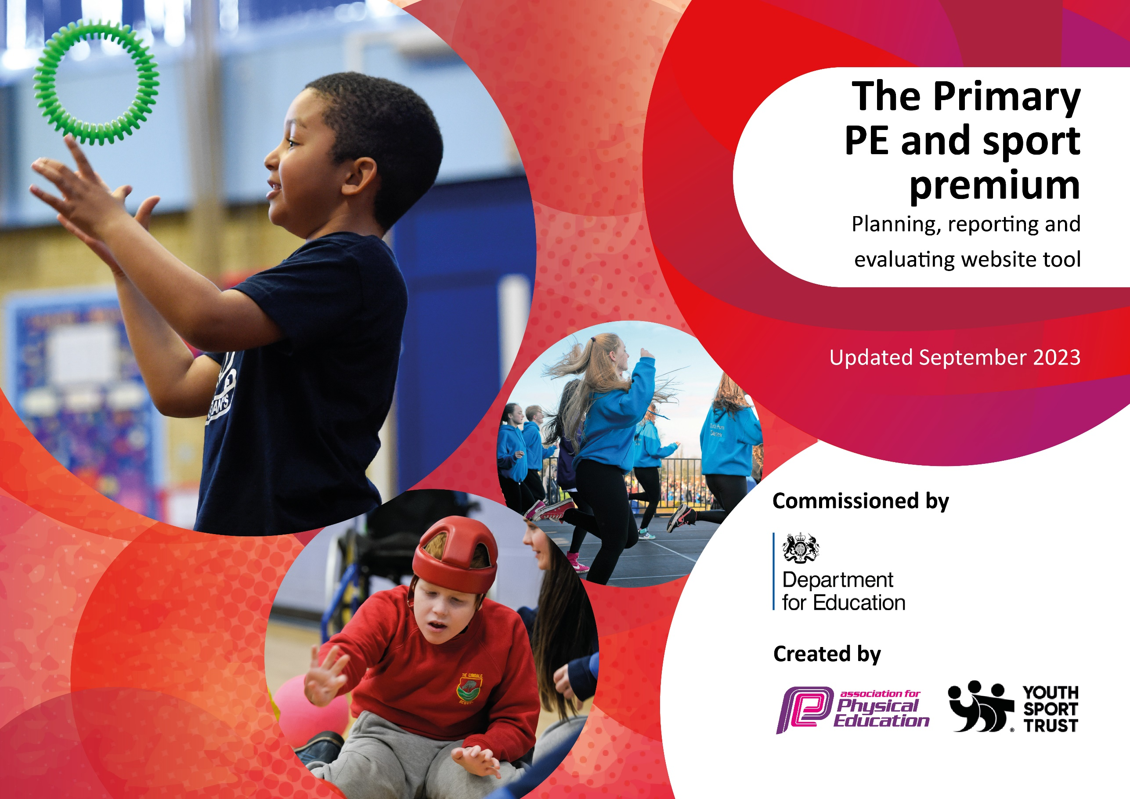

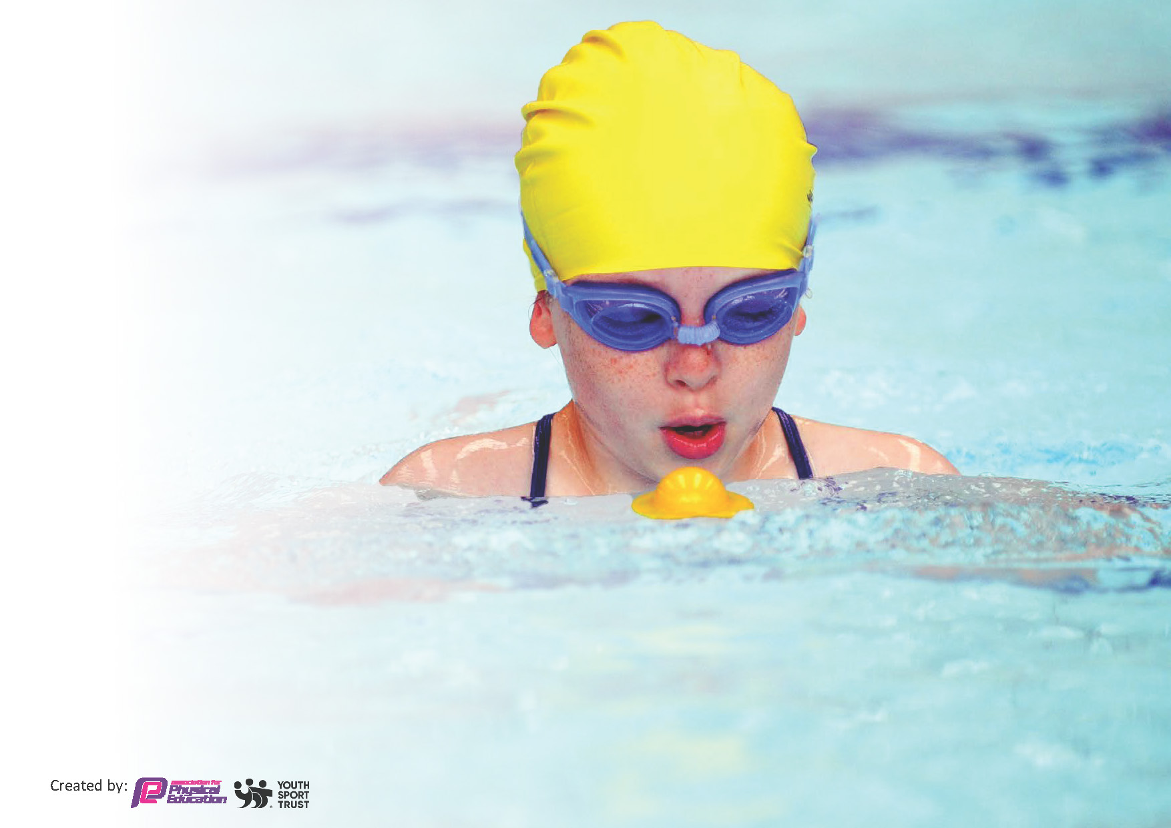
This template can be used for multiple purposes:
by:
- It enables schools to effectively plan their use of the Primary PE and sport premium
- It helps schools to meet the requirements (as set out in guidance) to publish information on their Primary PE and sport premium
- It will be an effective document to support Ofsted inspections enabling schools to evidence progress in Physical Education (PE) and evidence swimming attainment, which forms part of the PE National Curriculum. We would recommend schools consider
the Intent, Implementation and Impact of any spend, as examined within the Education Inspection Framework.

It is important that your grant is used effectively and based on school need.

Schools must use the funding to make additional and sustainable
improvements to the quality of the PE, School Sport and Physical Activity (PESSPA)
they offer. This means that you should use the Primary PE and sport premium to:

- Build capacity and capability within the school to ensure that improvements made now will benefit pupils joining the school in future years
- Develop or add to the PESSPA activities that your school already offers.

The Primary PE and sport premium should not be used to fund capital spend projects; the school’s core budget should fund these. Further detail on capital expenditure can be found in the updated Primary PE and sport premium guidance.

The Primary PE and sport premium guidance, outlines 5 key priorities that funding should be used towards. It is not

necessary that spending has to meet all the key priorities, you should select the priorities that you aim to use any funding towards.

Although completing this template is not a requirement for schools, schools are required to publish details of how they spend this funding. Schools must also outline what the impact this funding has had on pupils’ PE and sport participation and attainment and how any spending will be sustainable in the future. All funding must be spent by 31st July 2024.

The Department for Education has worked closely with the Association for Physical Education (afPE) and the Youth Sport Trust (YST) to develop this template and encourages schools to use it. This template is an effective way of meeting the reporting requirements of the Primary PE and sport premium.
Review of last year’s spend and key achievements (2022/2023)

We recommend you start by reflecting on the impact of current provision and reviewing your previous spend.

Activity/Action | Impact | Comments
KS2 Sports day took place outside of the school grounds with encouragement of parent support and participation.  Year 4 swimming lessons in state-of-the-art facilities taught professionally.  Teacher CPD for multiple sports  Use of external coaches | Making family memories which should cross offer with extracurricular intent as a family.  All children have gained water confidence and the ability to react well in water. A skill gained for life.  The standard of teaching is raised amongst all year groups in the teaching of PE. Teachers are able to vary lessons and techniques in a range of sports.  Afternoon and evening sports coaches brought in to facilitate specialty lessons such as girls’ participation or SEND activities. | Healthy families’ lifestyles are still being promoted across school with regular parent feedback.  Swimming with extra topped up lessons continues to prove successful and key to their sporting development.  Increasing and improved enthusiasm and confidence around the teaching of PE in school is maintained.  Child participation in extra curricula sports has increased leading to an increase in higher attainders in lesson.

Key priorities and Planning
This planning template will allow schools to accurately plan their spending.

Action – what are you planning to do | Who does this action impact? | Key indicator to meet | Impacts and how sustainability will be achieved? | Cost linked to the action
Participation in girls and boys football league  Maintaining safe and effective equipment indoor and outdoor for PE  Purchase of new equipment  Additional swimming lessons for Year 4 pupils  External agencies come in and showcase practical workshops.  Purchase of sports day facilities  Ensuring children complete orienteering activities as part of the national curriculum  Children are able to use a range of explorative equipment at break and lunchtimes.  Enquiring and receiving free equipment and resources from sporting bodies  Continue to buy-in to Primary PE Planning (PPP) for differentiated schemes of work and ensure there is a broad curriculum covering many different areas of skills and sports.  Use PPP to select appropriate MTPS that are differentiated and can ensure the teacher is teaching high-quality differentiated lessons.  Purchase medals/stickers and trophies to give to children who are making the effort to stay active.  Train Sports Leaders to lead a range of different activities in the playground - training in school and through Newham School Sports Partnership  Book with Chance 2 Shine for a cricket coach to come and teach a year group.  Book Bikeability for Years 3-6 children.  Book a fundraising athlete event for all children nursery – reception and above.  Create 'in class' PE lessons looking at the theory behind different sports (such as muscles used, bones affected etc) for UKS2 to use during WET PE lessons.  Send GoNoddle link and monitor that this is used for LKS2, KS1 and EYFS when WET PE takes place.  Create and update the PE display board, celebrating sport in our school.  Take part in events offered through NSSP and Newham Schools Football league.  Embedded intra school competitions in the MTPS so each half term children can compete with each other in their year groups and also ensure Sports Day is packed with events celebrating and showcasing a range of skills taught this year - not just athletics focus but focusing on other sporting skills like batting, throwing etc.  Invite schools within the trust and other schools within our connection to come to our school to participate in interschool competitions.  PE insets to cover knowledge of areas of the curriculum and skills children will learn.  Expand the range of activities available as extracurricular clubs to encourage pupils to be more involved. | Boys and girls across years 5 and 6 have a stable and regular footballing competition to encourage competitive participation. Girls and boys matches have seen a 50% increase over the last 2 years  Staff and pupils gain motivation and confidence in their lessons.  New equipment given through funding allows pupils to try new sports.  All pupils in year 4 have access to swimming lessons which include water safety.  Children have the chance to experience and take part in professional sporting opportunities.  Allowing pupils to compete with each other at an external venue to show importance with parent support and participation.  Children are taken to fair play house to take part in OAA skills.  More children are playing different games during break time and lunch time.  New equipment given through funding allows pupils to try new sports.  Children are being exposed to a broader PE curriculum, covering lots of skills with different sports.  Children are more motivated to be active in school during PE lessons and play time to receive the rewards offered.  Trophies offered half termly to 2 pupils in each class, medals offered weekly, and stickers offered daily.  Sports leaders are engaging more children in the playground. They approach those who are alone or sitting down and encourage them to join in the games.  Year 4 children showed tremendous progress in cricket led by Chance 2 Shine via Essex cricket.  More Year 5/6 children are biking to school since completing the Bikeability course. Bike ability courses have seen a 100% increase in participation on the previous year due to popular demand.  Children were motivated to participate in the fitness circuit with an athlete (basketballer this year) and really engaged in the activities they did.  Children are now using these activities during PE warmups that they lead.  Children love seeing what's new on the PE board and also seeing themselves being celebrated for something other than written work.  Shaftesbury has joined and facilitated a range of events this academic year.  Children in school have been keen to be supporters and 30% more children have wanted to be more actively involved.  Children love Sports Day and have enjoyed practicing for the dance appreciation day in Summer 2.  More children are wanting to sign up to after - school clubs to join these teams. As we now have a wider and broader range of equipment, more children are staying active as they have more to use and more to play with.  All Sports Clubs have been fully booked and waiting lists had to be created for them as there was a lot of interest in children joining them this year.  This year, our low attainers have shown more progress than previous years as they have received extra intervention at lunch time and as teachers and the coaches have been teaching PE lessons together, children have been focuses for the Sports Coach / teacher during lessons. | Number 5 - Increased participation in competitive sport  Number 2 - Engagement of all pupils in regular physical activity  Number 3 - The profile of PE and sport is raised across the school as a tool for whole school improvement.  Number 2 - Engagement of all pupils in regular physical activity  Number 4 - Broader experience of a range of sports and activities offered to all pupils.  Number 4 - Broader experience of a range of sports and activities offered to all pupils.  Number 2 - Engagement of all pupils in regular physical activity  Number 3 - The profile of PE and sport is raised across the school as a tool for whole school improvement.  Number 2 - Engagement of all pupils in regular physical activity  Number 1 - Increased confidence, knowledge and skills of all staff in teaching PE and sport  Number 2 - Engagement of all pupils in regular physical activity  Number 2 - Engagement of all pupils in regular physical activity  Number 3 - The profile of PE and sport is raised across the school as a tool for whole school improvement.  Number 4 - Broader experience of a range of sports and activities offered to all pupils.  Number 1 - Increased confidence, knowledge and skills of all staff in teaching PE and sport  Number 1 - Increased confidence, knowledge and skills of all staff in teaching PE and sport  Number 3 - The profile of PE and sport is raised across the school as a tool for whole school improvement.  Number 5 - Increased participation in competitive sport  Number 5 - Increased participation in competitive sport  Number 5 - Increased participation in competitive sport  Number 1 - Increased confidence, knowledge and skills of all staff in teaching PE and sport  Number 2 - Engagement of all pupils in regular physical activity | Continuation of partnership and networking between schools. Greater links are developed with pupils outside of school.  Better equipment which is used for purposes will see years of continued usage for practical purposes.  New equipment packs often provide information for extracurricular and out of school opportunities.  Pupils who take part are water confident and have reached high stages in their swimming journeys.  External providers give pupils a chance to experience something new to allow a spike in interest.  Competing at the home of the Olympics allows our pupils are an unforgettable memory.  As reflected in the national curriculum, map reading is a valuable part of learning.  Children gain interest in the sport while playing exploratively leading to them wanting to participate more out of school.  New equipment packs often provide information for extracurricular and out of school opportunities.  Continue to buy-in to Primary PE Planning. This is sustainable as plans can be downloaded if we chose not to continue with the purchase of the program.  Continue to use GoNoddle and use this to replace 5-a-day in EYFS.  Join NSSP next year to benefit from events and additional offers such as sporting challenges, Sports leader training and 1 after school club in the summer term.  Continue to purchase stickers, medals and trophies as rewards to help motivate children.  Ensure Sport Leader training for the new Year 6 cohort is done in the Autumn term.  Ensure Year 5 Sports Leader training takes place before the summer term through NSSP.  Re-book chance 2 shine and Bikeability if funding is still available. If funding is not available, enquire about the costs for these activities. Children at Shaftesbury really engage when outside specialist teachers come in.  Re-book an athlete visits for the next academic year - this is free, but children fundraise on behalf of the company.  All intents to continue in the next academic year.  Join NSSP for the next academic year.  Facilitate more events at Shaftesbury.  Create and attend events for the Boleyn Trust. Continue to reward children for participation and progression.  Continue to send staff/coaches and support staff on relevant CPD opportunities. Try to arrange for an inset for TAs (especially 1:1s).  Contact P.A from the Boleyn Trust to organise when coaches and 1:1s can go and observe SEN PE - timetabling prevented this from happening this academic year but they were trained/advised by the PE Coordinator.  Two thirds of SEN pupils who did not take part last year in PE are now actively joining in thanks to TA upskilling. | £594 – Primary PE Planning scheme subscription  £15 - NSSA membership  £2887.50 (NSSP membership)  £150 - London stadium hire  £795 – Top up swimming lessons  £600 - external workshops and events  £1210 - equipment purchase  £11592- clubs through premier education  £900 - CPD Level 5 training for sports coach  £594 – Primary PE Planning scheme subscription  £15 - NSSA membership  £2887.50 (NSSP membership)  £150 - London stadium hire  £795 – Top up swimming lessons  £600 - external workshops and events  £1210 - equipment purchase  £11592- clubs through premier education  £900 - CPD Level 5 training for sports coach  £594 – Primary PE Planning scheme subscription  £15 - NSSA membership  £2887.50 (NSSP membership)  £150 - London stadium hire  £795 – Top up swimming lessons  £600 - external workshops and events  £1210 - equipment purchase  £11592- clubs through premier education  £900 - CPD Level 5 training for sports coach  £594 – Primary PE Planning scheme subscription  £15 - NSSA membership  £2887.50 (NSSP membership)  £150 - London stadium hire  £795 – Top up swimming lessons  £600 - external workshops and events  £1210 - equipment purchase  £11592- clubs through premier education  £900 - CPD Level 5 training for sports coach

Key achievements 2023-2024
This template will be completed at the end of the academic year and will showcase the key achievements schools have made with their Primary PE and sport premium spending.

Activity/Action | Impact | Comments
The impressive and diverse number of clubs offered at school is something of a rarity in primary schools.  Purchase of external workshops  May24 achievements to be added | Pupils are able to expand their sporting ability outside the classroom to increase an interest in additional sports that may not fall into the national curriculum.  Pupils gain valuable memories of athlete visits or dance performances with provide hands on experience delivered by professionals. | Pupils daily have access to a range of sporting extracurricular activities. Uptake in clubs from new pupils has increased 30% on last year due to greater interest.  Staff have also had a chance to be exposed to something new and exciting within that sporting area. They are now able to teach in alternative ways in that area.

Swimming Data
Meeting National Curriculum requirements for swimming and water safety.
Priority should always be given to ensuring that pupils can perform safe self-rescue even if they do not fully meet the first two requirements of the National Curriculum program of study

Question | Stats: | Further context  Relative to local challenges
What percentage of your current Year 6 cohort can swim competently, confidently and proficiently over a distance of at least 25 metres? | 78.2% | Number relates to pupils who are confident in this area. Assessed by a professional swimming instructor and overseen by PE coordinator.  Reason for a number lower than 100% is due to absence on the day, new pupil intake and a lack of swimming practice since learning with the school.
What percentage of your current Year 6 cohort can use a range of strokes effectively [for example, front crawl, backstroke, and breaststroke]? | 62.7% | Number relates to pupils who are confident in this area. Assessed by a professional swimming instructor and overseen by PE coordinator.  Reason for a number lower than 100% is due to absence on the day, new pupil intake and a lack of swimming practice since learning with the school.  The school are actively looking at moving to a longer block based session to help increase this number of 70%

What percentage of your current Year 6 cohort are able to perform safe self-rescue in different water-based situations? | 80% | Number relates to pupils who are confident in this area. Assessed by a professional swimming instructor and overseen by PE coordinator.  Reason for a number lower than 100% is due to absence on the day, new pupil intake and a lack of swimming practice since learning with the school.  Water rescue has been prioritized due to its importance.
If your schools swimming data is below national expectation, you can choose to use the Primary PE and sport premium to provide additional top-up sessions for those pupils that did not meet National Curriculum  requirements after the completion of core lessons. Have you done this? | No
Have you provided CPD to improve the knowledge and confidence of staff to be able to teach swimming and water safety? | No | Lessons taught externally by swimming professionals

Signed off by:

Head Teacher: | Geoff Hadlow
Subject Leader or the individual responsible for the Primary PE and sport premium: | Noah Lown
Governor: | Mohammed Mamun (SEND link governor)
Date: | 27/03/24

